**Installing MySQL Server**

1. Go the link : <https://dev.mysql.com/downloads/mysql/5.5.html?os=3&version=5>

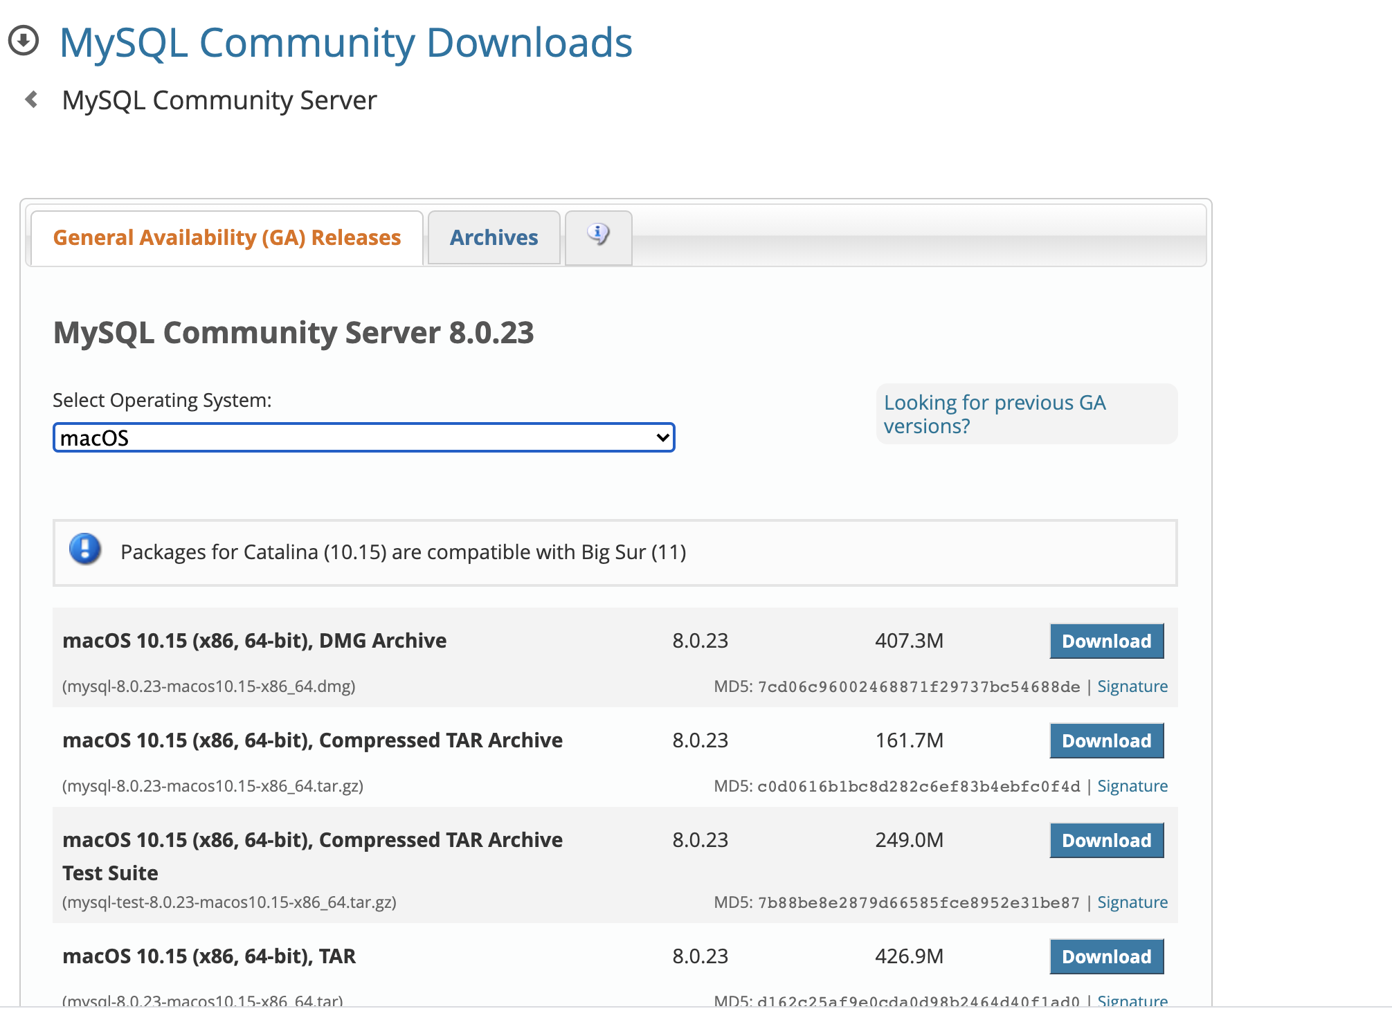

1. Once on the website, click on Archives tab
   1. On the Archives tab select the **8.0.20** product version. Your operating system should be automatically selected

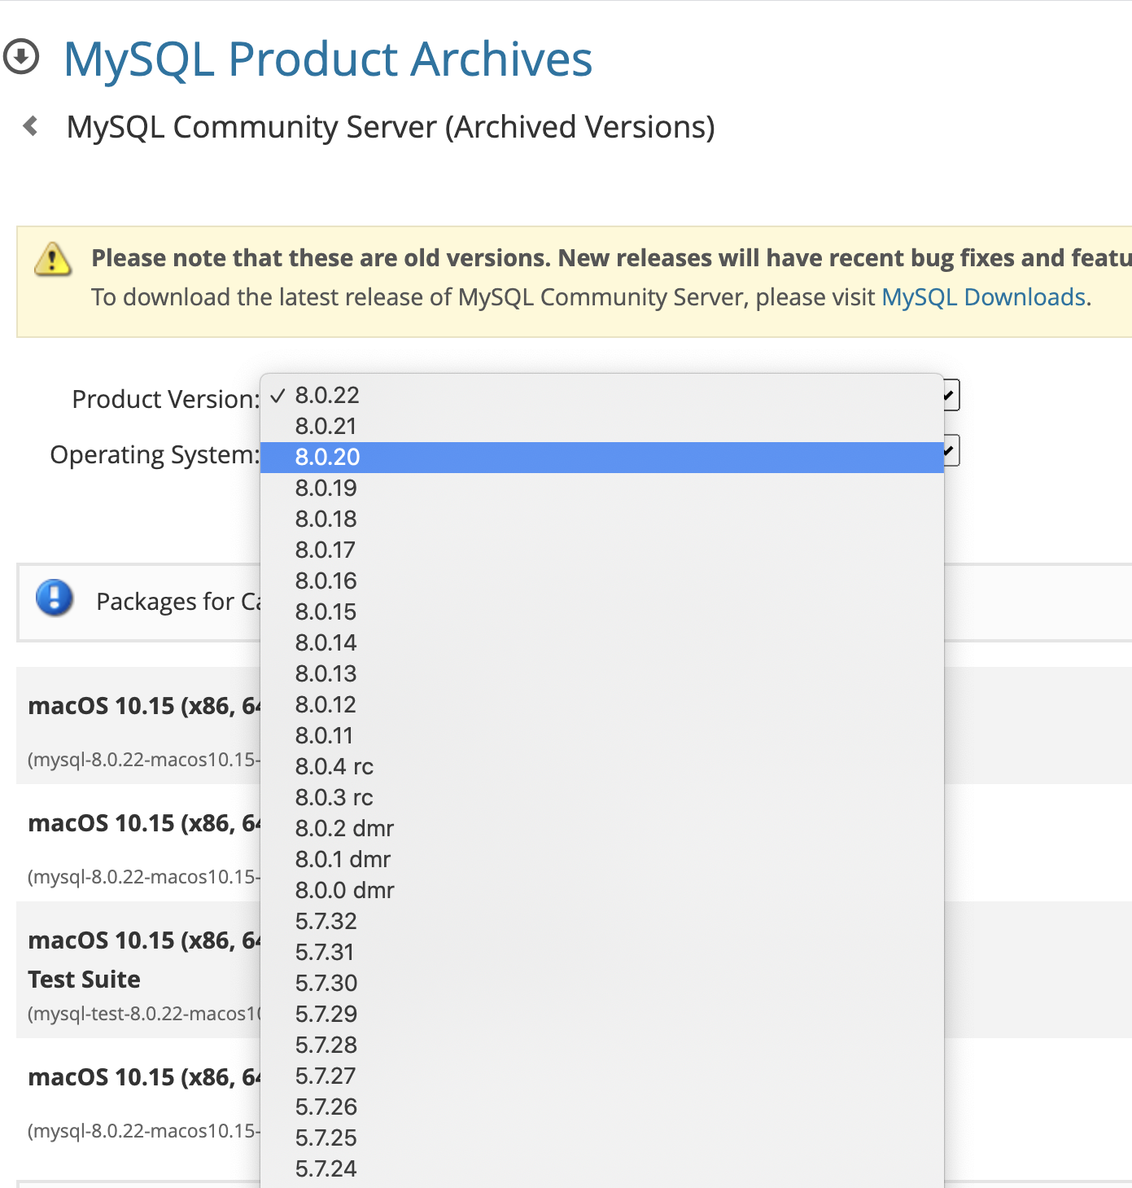

1. Click on the DMG archive option for based on your system

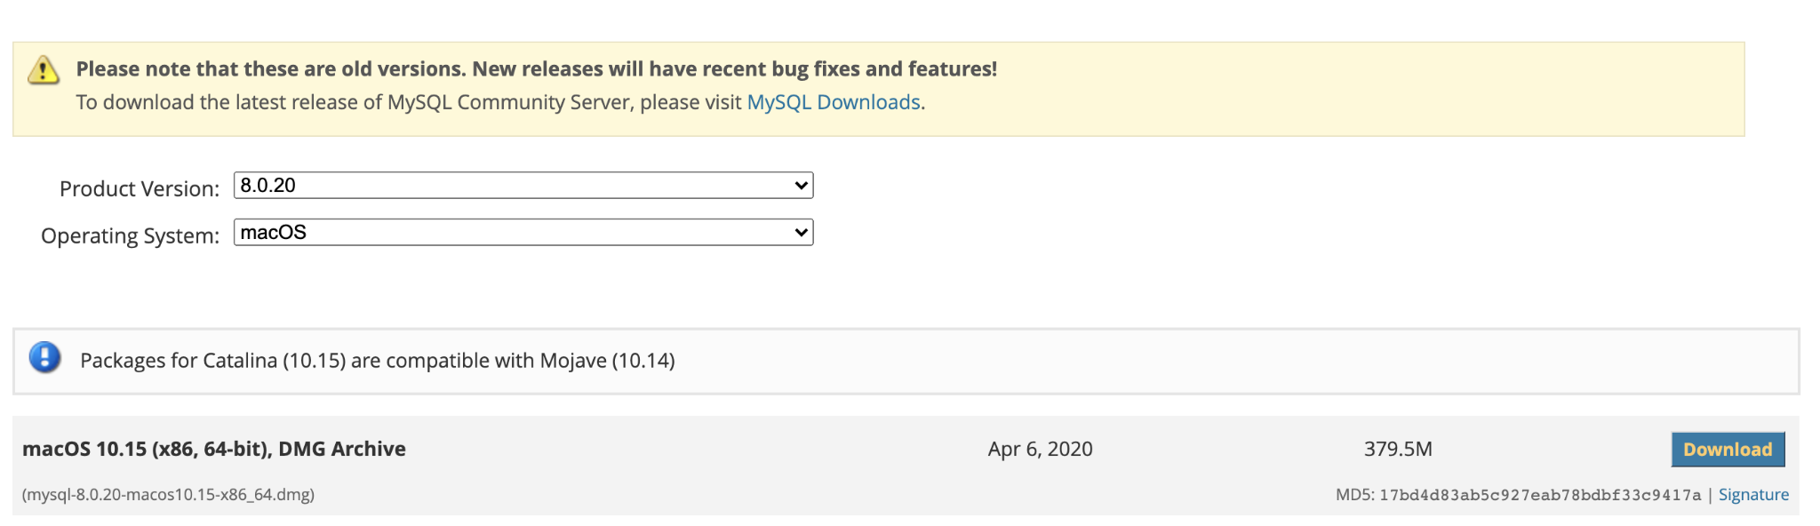

1. The file should get automatically downloaded. Once the download is complete, click on the downloaded file to open it.
   1. If your system doesn’t allow you to open the file (for example: in a mac) go to your system preferences in order to allow that application to run.
2. Once the application to download MySQL server opens, just keep on clicking on continue and next wherever it prompts you to.

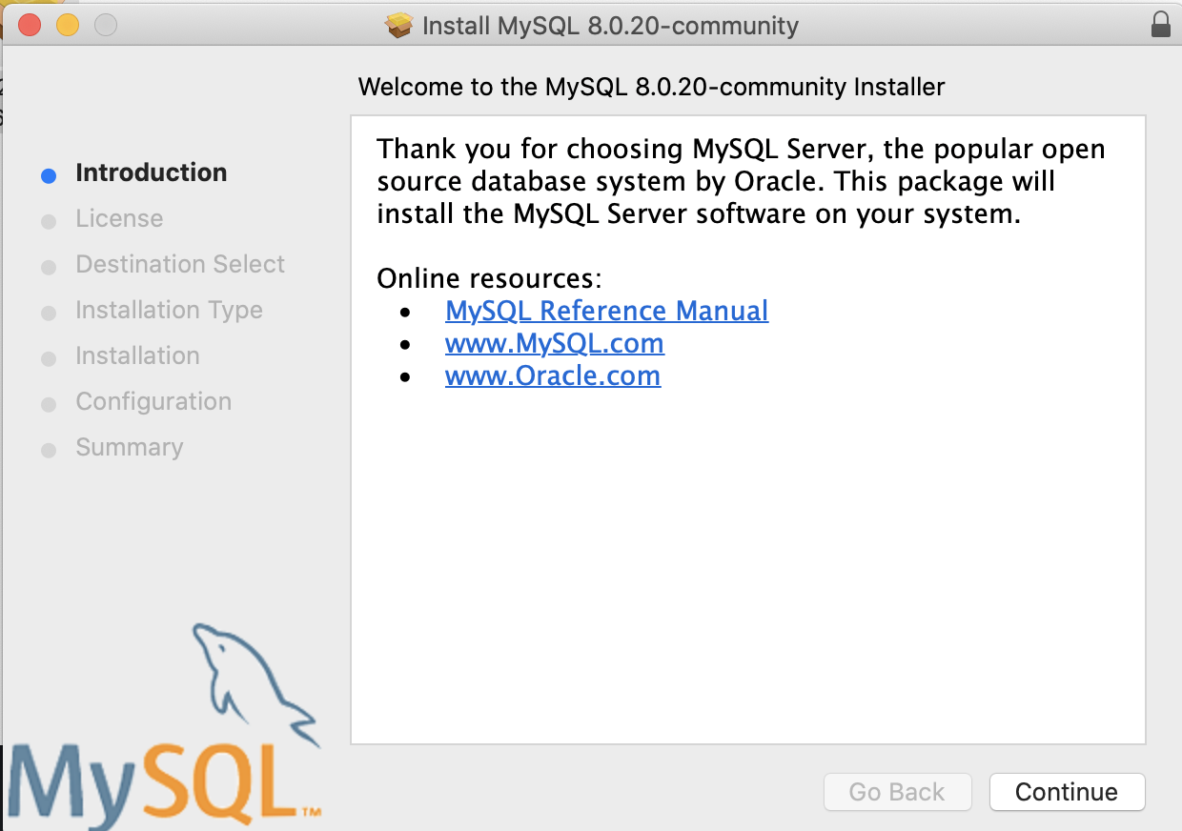

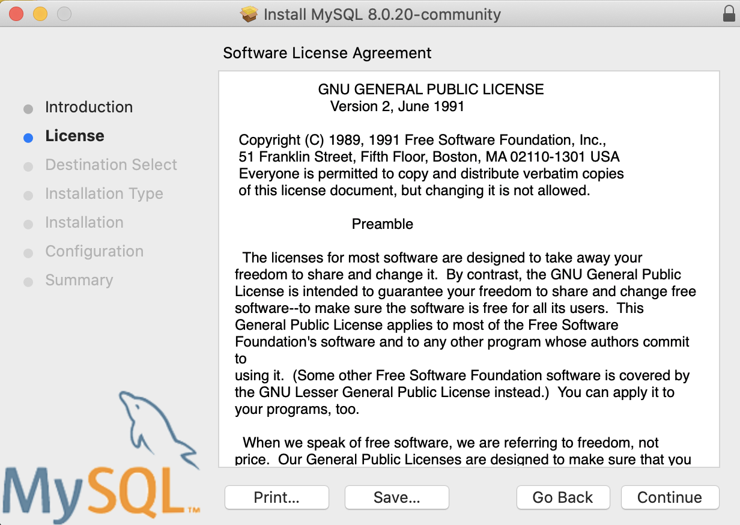

* Accept the license agreement

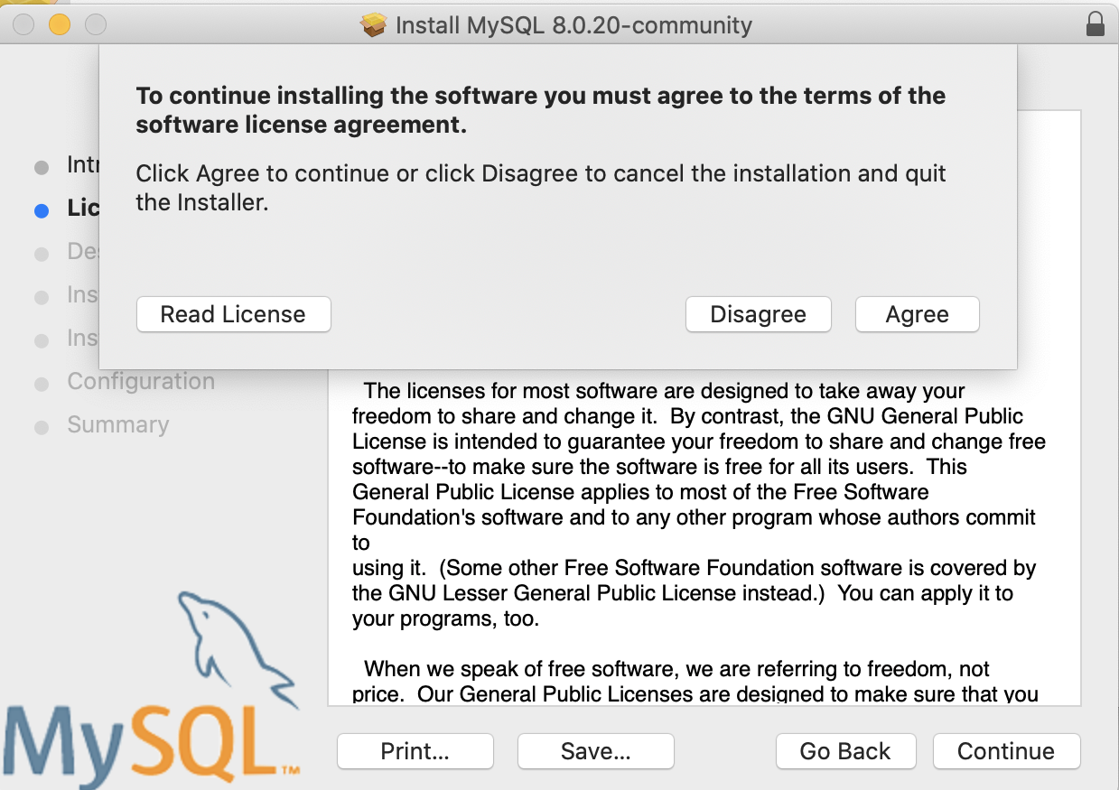

* Click on install

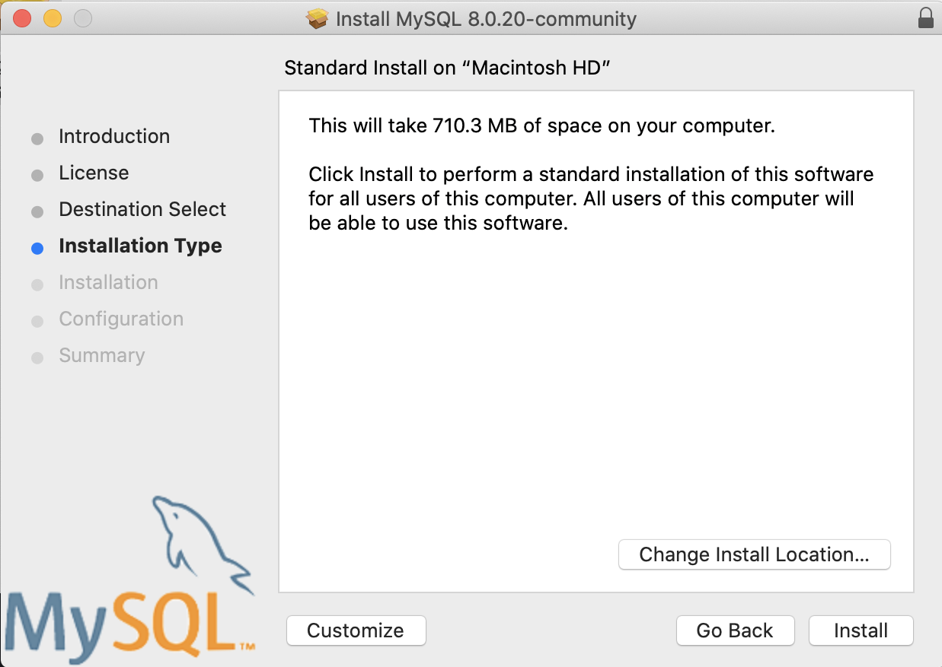

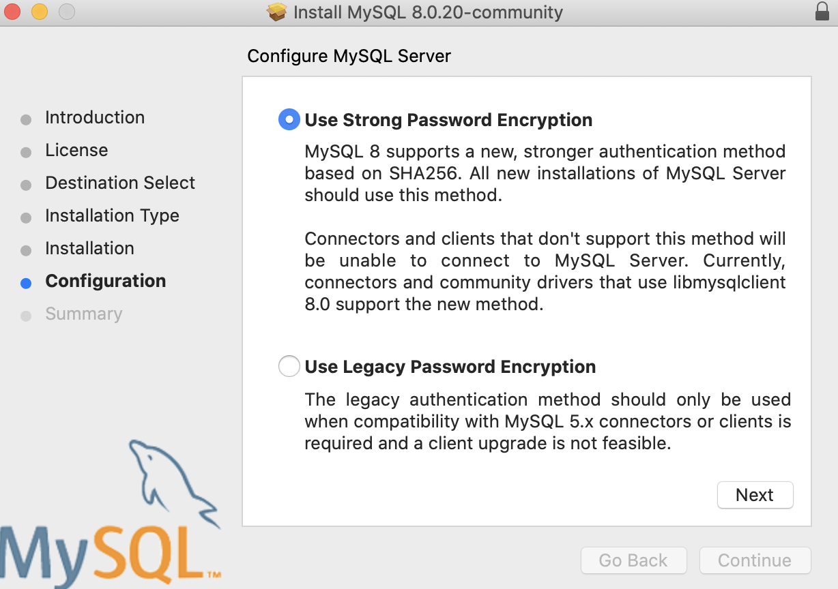

* Create a password for your root user. **Make sure that you note this password** as you will be referring to it again and again whenever you connect to the database.

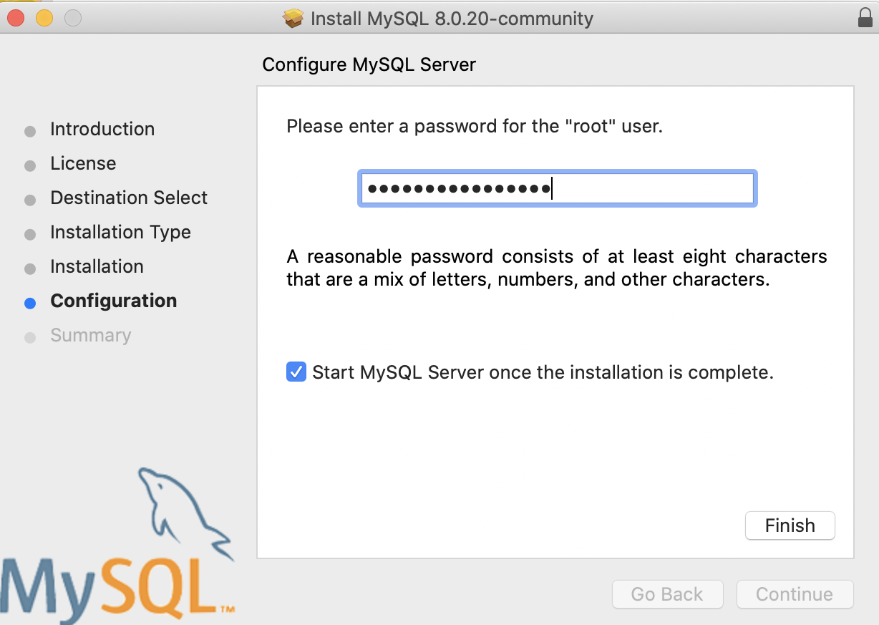

**Installing MySQL Workbench**

1. Go to the link: <https://dev.mysql.com/downloads/workbench/>

* Click in the archives tab

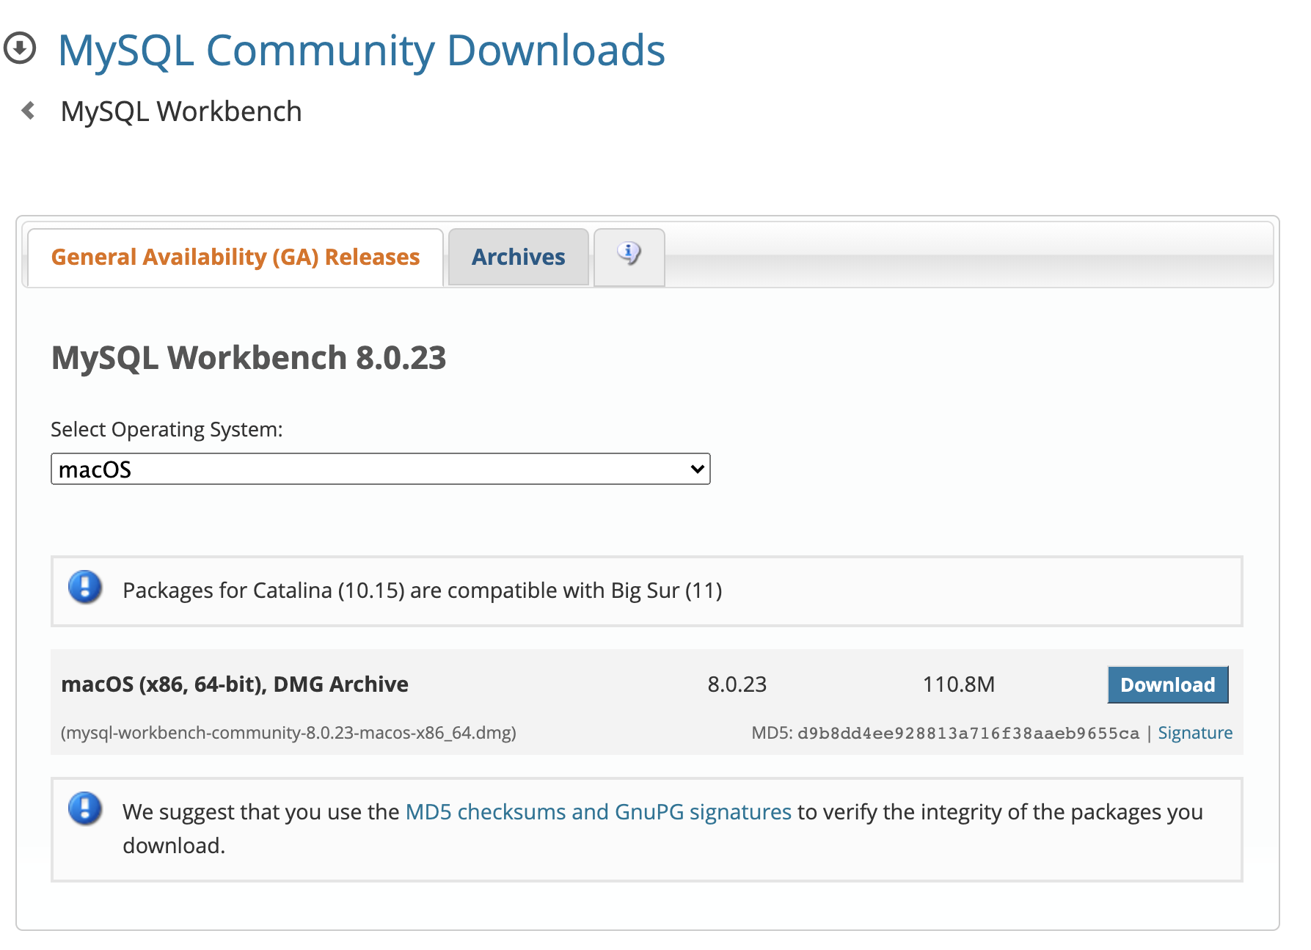

* Select product version as 8.0.20

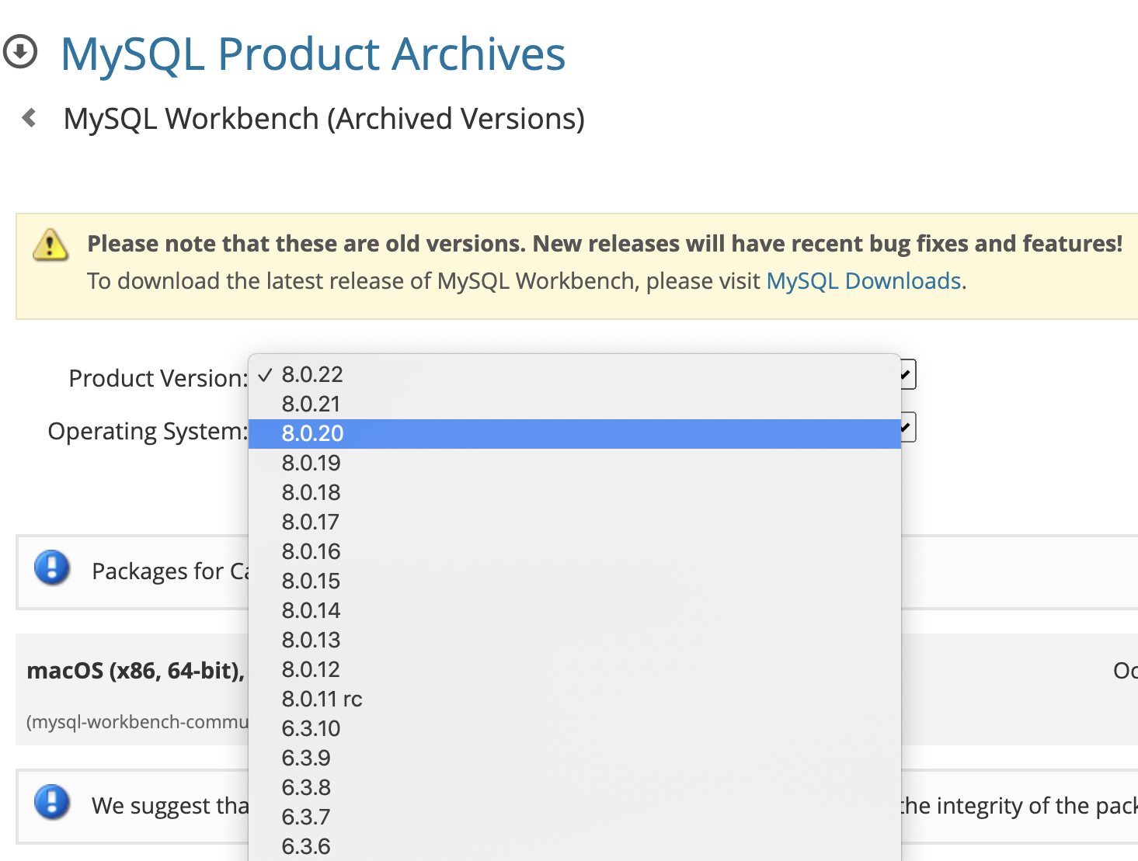

* Click on the DMG archive download button. The application will automatically download.

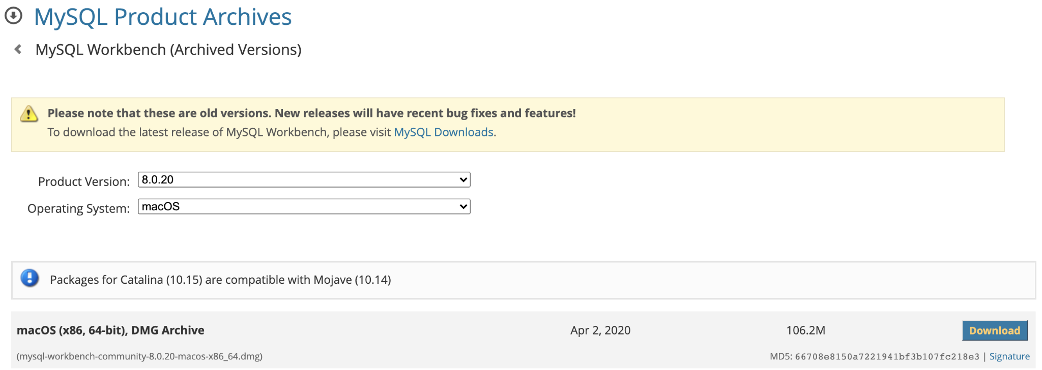

* Open the downloaded folder, MySQL workbench should be installed on your system. Once installed the application should look how it has been shown below:

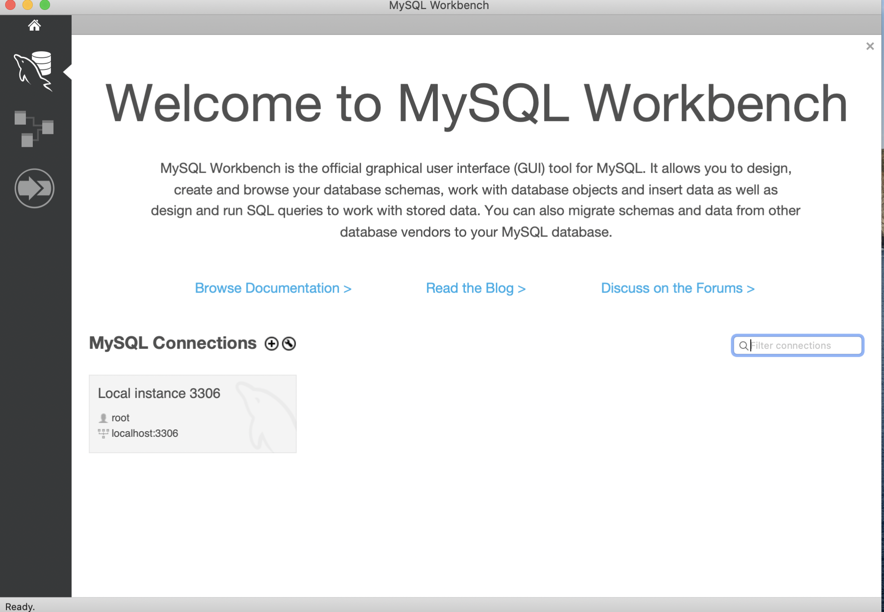

* Enter the password to connect to the root user:

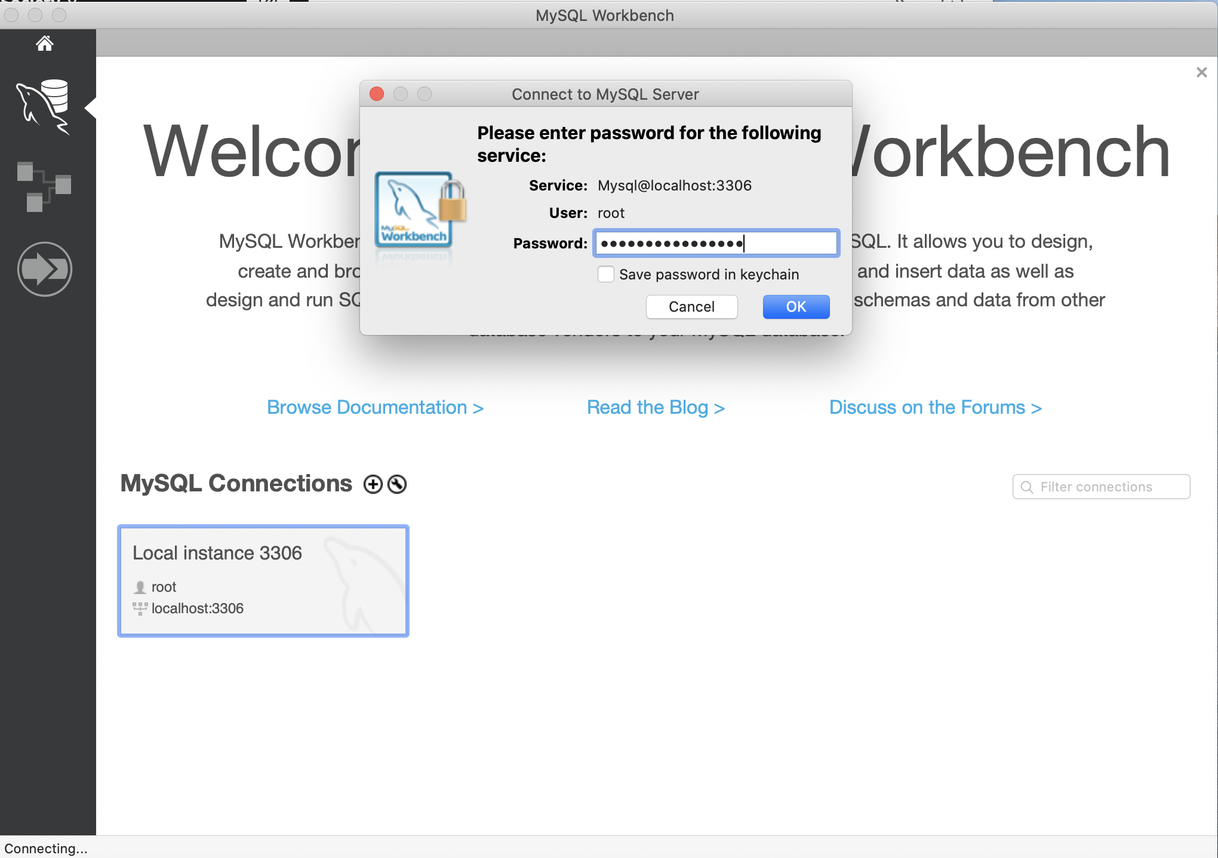

* You are now ready to write your SQL queries

